Case Report
Management of complex luxation injuries by surgical repositioning of maxillary anterior teeth: a case report
Dr. Sujith Gopalan^{1 ,} Dr. Shantanu Choudhari² , Dr. Swati Goyal³ , Dr. Kinjal Vekariya⁴
Dr. Jigna Vaghasiya⁵ , Dr. Sruthi Chandra⁶

Department of Pedodontics and Preventive Dentistry
Corresponding author: Dr.Shantanu Choudhari

ABSTRACT:
Luxation injuries are one of the severe traumatic dental injuries. Intrusive luxation is one of the most severe among these that causes a great damage to pulp and periapical tissue. Management of these injuries becomes more challenging when luxation injuries are associated with the crown and/or root fracture. The present case report describes one such case of severe intrusion of right maxillary central incisor and extrusive luxation of right maxillary lateral incisor along with varying degree of crown fractures that was managed by surgical repositioning of both the teeth followed by endodontic treatment and composite resin restoration.
KEYWORDS: Trauma, Fracture, Luxation, Intrusion, Extrusion.

INTRODUCTION:
Children and teenagers account for the great majority of traumatic dental injuries (TDI), where losing a tooth can have long-term effects. Traumatic intrusion is a type of injury that causes axial displacement of the tooth toward the alveolar bone. Intrusive luxation (as it is more properly known) typically affects the anterior teeth and is frequently linked to an affected fracture of the alveolar bone. These injuries account for approximately 15-61% of traumatic injuries in permanent dentition.⁽¹⁾ Extrusive luxation is a type of traumatic injury mainly caused by forces with oblique direction, characterized by the partial or total separation of periodontal attachments^{(2).} The involved tooth appears elongated in oral cavity hence also termed as “partial avulsion”, has a risk of loss of vascular supply and pulp vitality. These effects will have a long term complications like pulp necrosis, root canal obliteration, ankylosis, replacement resorption, inflammatory root resorption and/or loss of marginal bone support that may sometimes lead to ultimate loss of the involved tooth.⁽³⁾
Apart from these complications, these traumatic injuries can have long lasting psychological repercussions on both the child's parents and the child themselves. Children with untreated dental disorders typically demonstrate low self-esteem and are less satisfied with their looks, which can cause major social issues.⁽⁴⁾ The present case report describes the management of complex traumatic injuries that includes combination of severe intrusive luxation along with Ellis class II fracture of maxillary central incisor and extrusive luxation in maxillary lateral incisors in a 12 years old child.
CASE REPORT
A 12 years old child reported to the Department of Pedodontics & Preventive Dentistry, GDCH Ahmedabad with chief complain of fractured upper front teeth. Child’s Parent gave a history of trauma due to fall from stairs 1 week ago. Medical History was non-contributory. Clinical Examination showed a severely intruded maxillary right central incisor and moderately extruded maxillary right lateral incisor along with an Ellis Class I fracture and Ellis Class II Fracture in maxillary left central incisor.(Fig 1) All the three involved teeth were tender to percussion tests. Electric Pulp testing showed no response in tooth #11 & #12 and variable response in tooth #21. Tooth #12 showed a Grade I mobility. Radiographic Examination included an OPG, Maxillary Occlusal Radiograph and an Intra Oral Periapical Radiograph. (Fig 2)

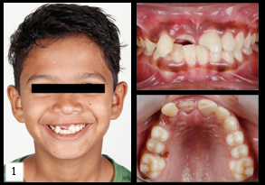
Fig 1 : Pre-Operative Clinical Photos

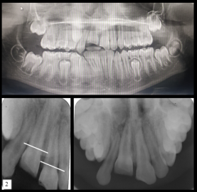
Fig 2 : Preoperative Radiographic Photos

Considering the Cemento Enamel Junction as a reference point, the amount of intrusion was measured and owing to the recent history of trauma, Pulp vitality testing response were not taken into consideration. Therefore, a final diagnosis of (a) Severe Intrusive Luxation(≥7mm) with Ellis Class II Fracture in tooth 11, (b) Extrusive Luxation with Ellis Class I Fracture in tooth #12 and (c) Ellis Class II Fracture in Tooth #21 was made.
Since the tooth was severely intruded (approximately 7mm) Surgical repositioning of tooth #11 and #12 was planned followed by flexible splinting for 4 weeks. Patient’s parents were informed about the possible consequences of the present situation and the treatment strategies were explained to the patient in their own language. A written informed consent was then obtained from the parent.
First of all, an infiltration anaesthesia in labial vestibule and nasopalatine nerve block to anesthetize the palatal mucosa was given with 1ml of Lignocaine Hydrochloride with Adrenaline (1:100,000 dilution). After the adequate anaesthesia was achieved, tooth to be extruded(#11) was first loosened inside the socket with a dental extracting forceps and extruded to the desired position.(Fig 4). After that the tooth to be intruded(#12) was intruded by holding the tooth with the forceps and gently pushing it back into the socket. Position of both the teeth was confirmed with an IOPA followed by placement of a passive and flexible splint for period of 4 weeks. However splinting these teeth were quite challenging owing to the unerupted right canine tooth. Therefore splinting was done involving maxillary right second premolar to maxillary left canine with orthodontic ligature wire. Patient was relieved after prescribing prophylactic antibiotics and analgesics along with a chlorhexidine containing mouthwash to facilitate oral hygiene during the splinting phase. Patient was advised to strictly adhere to soft diet and oral hygiene instructions as explained and was recalled after 3 days.
On the next appointment, Endodontic Treatment was initiated in tooth #11 and #12. Pulp extirpation was done and root canals was irrigated with 3% Sodium Hypochlorite and 0.9% Normal saline. Intracanal medication was given with aqueous Calcium Hydroxide for 2 weeks. Since tooth #21 gave a variable response, endodontic treatment was deferred for 2 weeks and kept on follow up.
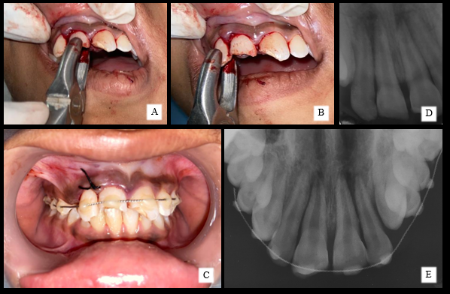
Fig 3: Surgical Extrusion of #12(A) , Surgical Intrusion of #11(B), IOPA After surgical repositioning(D), Placement of flexible splint(C), Occlusal Radiograph after splinting(E)

On the next appointment, an uneventful and satisfactory healing was observed. Root canal treatment was completed by obturating tooth #11 and #12 with lateral condensation of gutta percha. Electric Pulp testing was performed on tooth #21. No response was seen after EPT and cold sensibility testing. Therefore endodontic treatment was performed for tooth #21 as well.
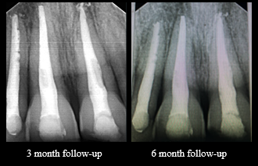
Fig 4: Radiographic Images of 3 months and 6 months follow up

Splinting was removed after 4 weeks as no signs of mobility was evident in any of the repositioned teeth. On the subsequent appointment, restoration of the fracture #11, #12 and #21 was done by direct composite restoration. Fig (4) shows the follow up after 3 months and after 6 months. Fig (5) shows follow up after 1 year.

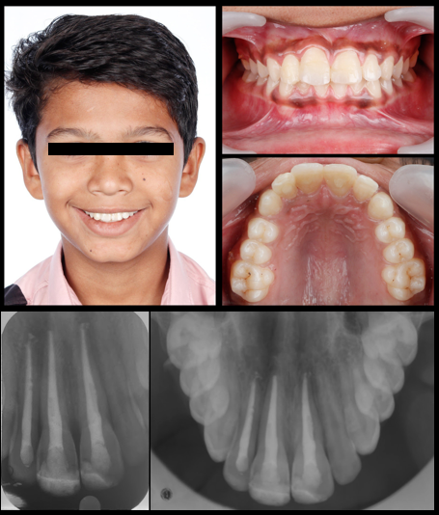

Fig : 5 Follow Up after one year.
DISCUSSION
Trauma of the oral and maxillofacial region occurs frequently and comprises 5% of all injuries for which people seek dental treatment. Major causes for these type of facial trauma have been described in the past literature that includes violence, collisions, falls, sports, leisure activities, and traffic accidents^{(5,6,7).} It has been also suggested that the age group of 7- 12 years is the most prone to these type of traumatic injuries with boys sustain these injuries more frequently as compared to girls.⁽⁶⁾ Patient subjected to the facial trauma can lead to fracture, displacement(also called as luxations) or sometimes complete loss of the tooth along with crushing, and/or fracturing of bone, and soft tissue injuries including contusions, abrasions, and lacerations that can have severe negative functional, aesthetic, and psychological implications. Apart from this, previous studies have also shown that maxillary arch is more susceptible as compared to mandibular with maxillary central incisor as the most frequently traumatised followed by maxillary lateral incisor and mandibular incisors.⁽⁸⁾
Luxation is the displacement or partial dislocation of a tooth from its socket. Undoubtedly, Intrusive luxation is one of the most severe injuries that can lead to pulp necrosis in 96.0% of cases of teeth with completely formed roots as described by JH Camp⁽⁹⁾. Infact, a study by Andreasen et al ⁽¹⁰⁾ revealed pulp necrosis in 100% of traumatically intruded teeth with open apices and in 62.5% teeth with incomplete root formation.
The combination of two different types of injuries occurring concurrently to the same tooth will be more detrimental than a single injury, creating a negative synergistic effect⁽¹¹⁾. Various treatment modalities has been suggested in the literature for these type of injuries that includes spontaneous re-eruption, orthodontic repositioning or surgical repositioning. Depending upon the degree of intrusion and the stage of root development the appropriate treatment plan can be made. The present case report as described involves a combination of luxation injuries including crown fractures. All the involved teeth had completed the root formation with closed apices. Since the patient already reported 1 week after the injury, period of one week was kept as observation. But unfortunately there were no signs of spontaneous reeruption of the intruded tooth. Therefore considering the severity of intrusion, (approx. 7mm) and mobility of the extruded #12, surgical repositioning of both the teeth was done on the second appointment. Another reason for doing surgical intervention in this case was to not allow time for bone remodelling that might cause difficulty in achieving splint stability after the repositioning.
Since the intrusive luxation is almost invariably associated with pulp necrosis of the involved tooth, Endodontic treatment was initiated on the next appointment. Apart from that, if the root canal treatment is not initiated within a period of 2-3 weeks in case of intrusion/extrusive luxation, external inflammatory resorption may occur that can further jeopardize the prognosis of the tooth ⁽¹²⁾.Fortunately in the present case, no tenderness/ metallic sound on percussion that signifies absence of any replacement resorption/ ankylosis.
CONCLUSION:
The course of treatment for intrusion injuries should be determined by a number of variables, including the degree of intrusion, patient compliance, the severity of the trauma, time elapsed post trauma etc. However once indicated, surgical repositioning should be done as early as possible to prevent the complications like root resorption and/or eventual loss of tooth.

REFERENCES:
- Andreasen fm, andreasen jo. Luxation injuries. In: andreasen jo, andreasen fm, editors. Textbook and color atlas of traumatic injuries to the teeth, 3rd edn. Copenhagen: munksgaard publishers; 1994.
- Mokhtari, s., hosseini, s., & khosrozadeh, m. (2021). Management of an extrusive luxation concomitant with subluxation: a case report with ten-year follow-up. Case reports in dentistry, 2021, 6256894. Https://doi.org/10.1155/2021/6256894
- De alencar ah, lustosa-pereira a, de sousa ha, figueiredo jh. Intrusive luxation: a case report. Dent traumatol. 2007 oct;23(5):307-12. Doi: 10.1111/j.1600-9657.2006.00461.x. Pmid: 17803489
- Elbay ü. Ş., baysal a., elbay m., sarıdağ s. Multidisciplinary approach to delayed treatment of traumatic teeth injuries involving extrusive luxation, avulsion and crown fracture. Operative dentistry. 2014;39(6):566–571. Doi: 10.2341/13-116-s.
- Bastone eb, freer tj, & mcnamara jr (2000) epidemiology of dental trauma: a review of the literature australian dental journal 45(1) 2-9.
- Dua r, & sharma s (2012) prevalence, causes, and correlates of traumatic dental injuries among seven-totwelve-year-old school children in dera bassi contemporary clinical dentistry 3(1) 38-41.
- Hecova h, tzigkounakis v, merglova v, & netolicky j (2010) a retrospective study of 889 injured permanent teeth dental traumatology 26(6) 466-475
- Filippi a, tschan j, pohl y, berthold h, & ebeleseder k (2000) a retrospective classification of tooth injuries using a new scoring system clinical oral investigations 4(3)173-175
- Camp jh. Diagnosis and management of sports-related injuries to the teeth. Dental clinics of north america. 1991 oct 1;35(4):733-56. Andreasen fm.
- Pulpal healing after luxation injuries and root fracture in the permanent dentition. Dental traumatology. 1989 jun;5(3):111-31.
- Bourguignon c, cohenca n, lauridsen e, flores mt, o'connell ac, day pf, tsilingaridis g, abbott pv, fouad af, hicks l, andreasen jo. International association of dental traumatology guidelines for the management of traumatic dental injuries:Fractures and luxations. Dental traumatology. 2020 aug;36(4):314-30.
- Andreasen jo, bakland lk, andreasen fm. Traumatic intrusion of permanent teeth. Part 3. A clinical study of the effect of treatment variables Such as treatment delay, method of repositioning, type of splint, length of Splinting and antibiotics on 140 teeth. Dent traumatol 2006; 22(2):99–111.

.

